2200030216 TASK 3 WEEK_1   
EXERCISE:-2 **E-commerce Platform Search Function  
file format  
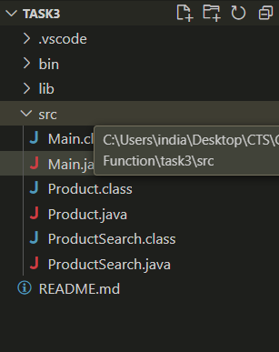**

Out put  
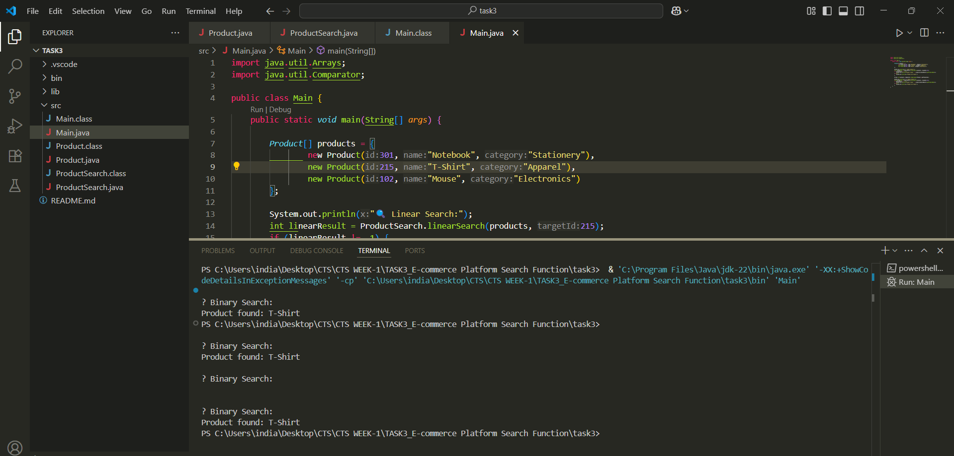

Main.java  
import java.util.Arrays;

import java.util.Comparator;

public class Main {

    public static *void* main(String[] *args*) {

*Product*[] products = {

                new Product(301, "Notebook", "Stationery"),

                new Product(215, "T-Shirt", "Apparel"),

                new Product(102, "Mouse", "Electronics")

        };

        System.out.println("🔍 Linear Search:");

        int linearResult = ProductSearch.linearSearch(products, 215);

        if (linearResult != -1) {

            System.out.println("Product found: " + products[linearResult].getProductName());

        } else {

            System.out.println("Product not found.");

        }

        Arrays.sort(products, Comparator.comparingInt(Product::getProductId));

        System.out.println("\n🔍 Binary Search:");

        int binaryResult = ProductSearch.binarySearch(products, 215);

        if (binaryResult != -1) {

            System.out.println("Product found: " + products[binaryResult].getProductName());

        } else {

            System.out.println("Product not found.");

        }

    }

}

PRODUCT.JAVA

public class Product {

    private *int* productId;

    private String productName;

    private String category;

    public Product(*int* *id*, String *name*, String *category*) {

        this.productId = *id*;

        this.productName = *name*;

        this.category = *category*;

    }

    public *int* getProductId() {

        return productId;

    }

    public String getProductName() {

        return productName;

    }

    public String getCategory() {

        return category;

    }

}

PRODUCTSEARCH.JAVA  
public class ProductSearch {

 public static *int* linearSearch(Product[] *products*, *int* *targetId*) {

        for (*int* i = 0; i < *products*.length; i++) {

            if (*products*[i].getProductId() == *targetId*) {

                return i;

            }

        }

        return -1;

    }

    public static *int* binarySearch(Product[] *products*, *int* *targetId*) {

*int* low = 0;

*int* high = *products*.length - 1;

        while (low <= high) {

*int* mid = low + (high - low) / 2;

*int* midId = *products*[mid].getProductId();

            if (midId == *targetId*) {

                return mid;

            } else if (midId < *targetId*) {

                low = mid + 1;

            } else {

                high = mid - 1;

            }

        }

        return -1;

    }

}